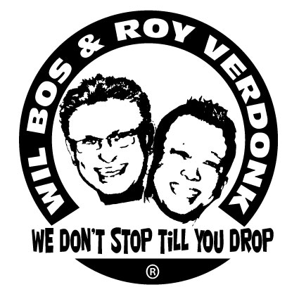
Babelonia

Choreographers : Wil Bos & Roy Verdonk
Level : Intermediate
Dance : 64 counts, 2 walls, 1 Tag
Muziek : Ricky L Ft.Meck - Born Again
Intro : 32 Counts from heavy Beat.

Skate R – L, Diagonal Shuffle Forward R, Skate L – R, Diagonal Shuffle Forward L
1-2 Skate RF forward to right, Skate LF forward to left
3&4 Step RF forward to right diagonal, Close LF next to RF, Step RF forward to right diagonal
5-6 Skate LF forward to left, Skate RF forward to right
7&8 Step LF forward to left diagonal, Close RF next to LF, Step LF forward to left diagonal

Jazz Box with ¼ Turn R, Out / Out, In place R, Touch Behind L
1-2 Cross RF over LF, ¼ turn right step LF back
3-4 Step RF to right side, Step LF forward
5-6 Step RF forward to right, Step LF forward to left (feet shoulder width apart)
7-8 Step RF back, Touch left toes back (3.00)

Swivel ¼ Turn L, Swivel ¼ Turn R, Shuffle Forward L, Step Press R, Recover on L, Shuffle Forward R
1-2 Turn ¼ left on both feet, Turn ¼ right on both feet (weight ends on RF)
3&4 Step LF forward, Close RF next to LF, Step LF forward
5 Step RF forward (push right hip forward)
6 Recover on LF (push left hip back)
7&8 Step RF forward, Close LF next to RF, Step RF forward (3.00)

Out L, Hold, Hip Roll With ¼ Turn L, Step Forward R, Hold, Hip Roll With ¼ Turn L.
1-2 Step LF to left side, Hold
3-4 Make a ¼ turn to the left ,whilst rolling hips CCW in 2 counts (weight on left)
5-6 Step RF forward, Hold
7-8 Make a ¼ turn to the left ,whilst rolling hips CCW in 2 counts (weight on left) (9.00)

Cross R, Point L to left, Point L in front, Hold, Close, Cross, Side, Sailor Step R
1-2 Cross RF over LF, Touch left toes to left side
3-4 Touch left toes in front of RF, Hold
&5-6 Close LF next to RF, Cross RF over LF, Step LF to left side
7&8 Cross RF behind LF, Step LF to left side, Step RF to right side (9.00)

Kick Ball Touch, Swivel ¼ Turn L, Swivel ¼ Turn R, Cross R, Point L to Left, Cross L, Point R to Right
1&2 Kick LF forward, Step on ball LF next to RF, Touch right forward (weight on left)
3-4 Turn ¼ left on both feet, Turn ¼ right on both feet ( weight on left)
5-6 Cross RF over LF, Touch left toes to left side
7-8 Cross LF over RF, Touch right toes to right side (9.00)

Step R forward, Pivot ½ Turn L, Dorethy Steps R – L, Kick Ball Touch
1-2 Step RF forward, ½ turn left
3-4& Step RF forward to right diagonal, Cross LF behind RF, Step RF forward to right diagonal
5-6& Step LF forward to left diagonal, Cross RF behind LF, Step LF forward to left diagonal
7&8 Kick RF forward, Step on ball of RF next to LF, Touch LF next to RF (3.00)

Ball Step R, Step L, Step R, Pivot ¾ L, Chasse R, Behind Side Cross
&1-2 Close LF next to RF, Walk forward R, Walk forward L
3-4 Step RF forward, ¾ turn left on LF
5&6 Step RF to right , Close LF next to RF, Step RF to right
7&8 Cross LF behind RF, Step RF to right , Cross LF over RF (6.00)

TAG (48 Counts) After Wall 3

1-2 bring both arms outwards to sides with palm of hands facing downwards on shoulderheight
3-4 cross both arms in front of chest with snakemovement inwards
5-6 cross both arms in front of chest with snakemovement outwards
7-8 bring both arms outwards to sides , this time with palm of hands facing upward on shoulderheight

1-4 bring arms from shoulderheight to position above head in circular movement with palm of hands towards eachother(like clapping)
5-6 bring both hands in same closed position downwards to chestheight(like praying)
7 open both hands horizontally(palms disconnect),whilst pushing downwards and forwards on chestheight, whilst fingertips are still
Connected and palm of hands are still facing downward.
& roll both hands inwards with back of hands against eachother(fingers pointing to body)
8 keep rolling hands inwards , finishing forward on chest height and palm of hands facing upward

This tag is done three times and after the first and second time you finished the 16 counts , you turn ¼ left

Wall 4 starts again to 12 o’clock wall

