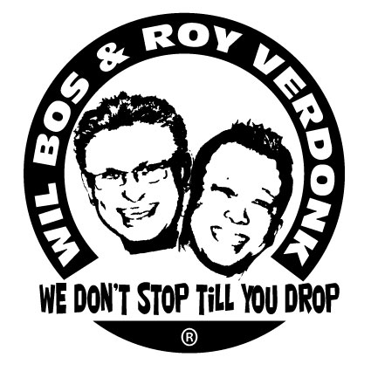
Hollywood

Choreographers : Roy Verdonk & Wil Bos
Level : Improver
Dance : 32 counts, 4 wall
Music : Michael Buble - Hollywood
Intro : 20 Counts
Note : in wall 8, you restart the dance after count 20

Diagonally shuffle forward R/L, jazzbox with 1/4 turn R
1&2 RF step diagonally forward, LF step together,step RF diagonally forward.
3&4 LF step diagonally forward, RF step together,LF step diagonally forward.
5-6 RF step across LF , make 1/4 turn R whilst stepping LF backward
7-8 RF step to right, LF scuff next to RF (3.00)

Jazzbox , cross shuffle R, rock L to left side, recover R with 1/4 turn L
9-10 LF step across RF, RF step backward
11-12 LF step to left side, RF scuff next to LF
13&14 RF cross in front of LF, LF step to left, RF cross in front of LF
15-16 LF rock to left, make 1/4 turn L whilst recovering on RF (12.00)

Rock back L, recover onto R, step L to left, touch R, vine right with 1/4 turn R
17-18 LF rock back, recover onto RF
19-20 LF step to left, RF touch next to LF* (restart dance here in wall 8)
22-22 RF step to right, LF cross behind RF
23-24 make 1/4 turn R whilst stepping RF forward, LF scuff next to RF (3.00)

Shuffle forward L, rock/recover, out/out, hold, in/in, hold
25&26 LF step forward, RF step together, LF step forward
27-28 RF rock forward, recover onto LF
&29 RF step to right, LF step to left( feet should be shoulderwidth apart)
30 hold
&31 RF step back to center, LF step next to RF
32 hold (3.00)
.
Start again smile and have fun

