Choreographers :
Adrian Churm (UK) Tel: +44(0)7710770580 E-mail:Danceade@hotmail.com 09-Nov-09 (Typo errors corrected)
John “Grrowler” Rowell (UK) Tel: +44 (0)1723 364736 Email: Grrowler@btinternet.com Web:www.Grrowler.com

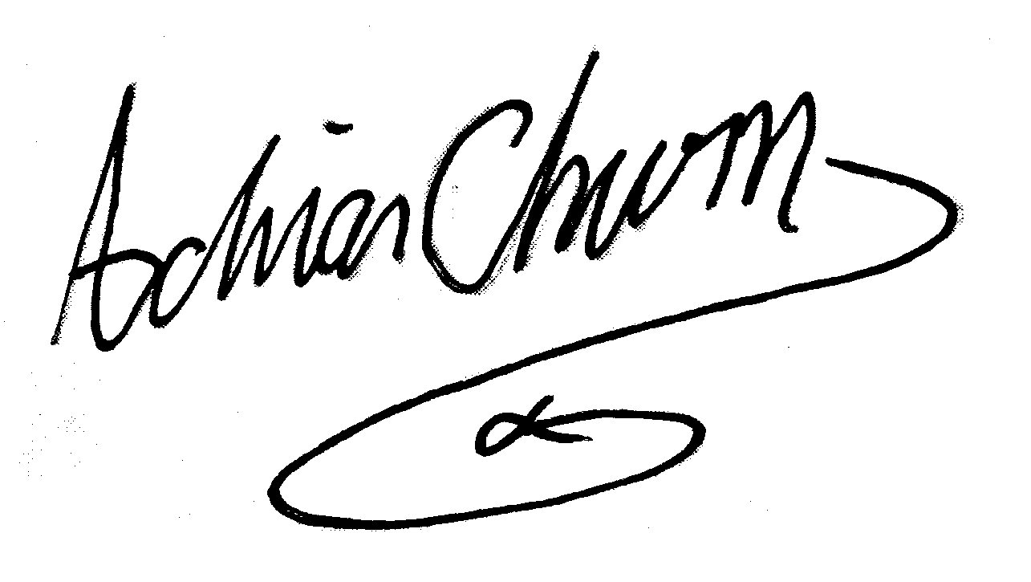
Description : 64 Count, 2 wall, Intermediate/Advanced Linedance

Music: "Disco Volante" by Fredrik Kempe Album: “Boheme” available at mp3city.com.ua
Intro: 32 counts / 18 secs (Main Vocals), 132 BPM

Rotation: N/A
Numbers in square brackets [ ] indicate facing wall and turn rotation. Start facing [12]

Sec 1 Right, left behind & heel & cross. Left, right behind & heel & cross
1-2& (1)Step right to right, (2)cross left behind, (&)step right to right [12]
3&4 (3)Tap left heel to left diagonal, (&)Step left next to right, (4)cross right in front of left [12]
5-6& (5)Step left to left, (6)cross right behind, (&)step left to left [12]
7&8 (7)Tap right heel to right diagonal, (&)step right next to left, (8)cross left in front of right [12]

Sec 2 Right, left behind & rock recover. One and a quarter triple turn, Rock recover
1-2& (1)Step right to right, (2)cross left behind right, (&)step right to right [12]
3-4 (3)Cross rock left over right, (4)recover on right [12]
5&6 (5)Step left quarter turn left, (&)half turn left stepping back on right, (6)half turn left stepping forward left [CCW, 9]
  - (7)Rock forward on right, (8)recover on left [9]

Sec 3 Half right, forward left. Syncopated rocks, Left back lock step
  - (1)Half turn right stepping right forward, (2)step left forward [3]
3-4& (3)Rock forward on right, (4)recover on left, (&)step back on right [3]
5-6 (5)Rock forward on left, (6)recover on right [3]
7&8 (7)Step back on left, (&)lock right across left, (8)step back on left [3]

Sec 4 Point back - half turn, Step forward - half turn, Heel tap – heel tap, Out - out
1-2 (1)Point right toe back, (2)half turn right stepping forward onto right [CW, 9]
  - (3)Step left forward, (4)pivot half turn right [CW, 3]
5&6 (5)Step left forward tapping heel (&)raise heel, (6)tap left heel [3]
On walls 1 and 3 place both hands over heart and pump in time with the heel taps
  - (7)Step right slightly right, (8)step left slightly left [3]

Sec 5 Cross rock – recover, Three quarter triple turn, Rock – recover, Coaster cross
  - (1)Cross rock right over left, (2)recover on left [3]
3&4 (3)Step right quarter right, (&)step left quarter right, (4)step right quarter right [CW, 12]
  - (5)Rock forward on left, (6)recover right [12]
7&8 (7)Step back on left, (&)step right next to left, (8)cross left over right [12]

Sec 6 Two modified Monterey half turns
  - (1)Point right to right, (2)half turn right stepping right next to left [6]
3&4 (3)Rock left to left, (&)recover on right, (4)cross left over right [6]
5-6 (5)Point right to right, (6)half turn right stepping right next to left [12]
7&8 (7)Rock left to left, (&)recover on right, (8)cross left over right [12]

Sec 7 Step right – Hold, Sailor quarter turn left, Two step full turn, Step - turn - step
  - (1)Step right to right, (2)hold [12]
3&4 (3)Step left behind right turning quarter left, (&)step right slightly right, (4)step left slightly forward [CCW, 9]
  - (5)Half turn left stepping back on right, (6)half turn left stepping forward on left [CCW, 9]
7&8 (7)Step right forward, (&)pivot half turn left, (8)step right forward [CCW, 3]

Sec 8 Left Dorothy step, Right Dorothy step, Step – Quarter pivot, Crossing shuffle
1-2& (1)Step left forward on left diagonal, (2)lock right behind left (&)step left forward on left diagonal [3]
3-4& (3)Step right forward on right diagonal, (4)lock left behind right, (&)step right forward on right diagonal [3]
5-6 (5)Step left forward, (6)pivot quarter turn right [CW, 6]
7&8 (7)Cross left over right, (&)step right to right, (8)cross left over right [6]

Choreographers notes:
During wall 5 the music slows down – dance at normal tempo up to count 1, section 4.(Point right toe back)
Counts 1-8 at slow speed and then pick up the tempo on count 1, section 5 (Cross rock)

The music is based on a theme from Khachaturian's ballet – Spartacus, hence the name
It was used for the BBC’s TV series – “The Onedin Line”

